Memory hierarchy

Memory Hierarchy, in Computer System Design, is an enhancement that helps in organising the memory so that it can actually minimise the access time. The development of the Memory Hierarchy occurred on a behaviour of a program known as locality of references. Here is a figure that demonstrates the various levels of memory hierarchy clearly:

Memory hierarchy design

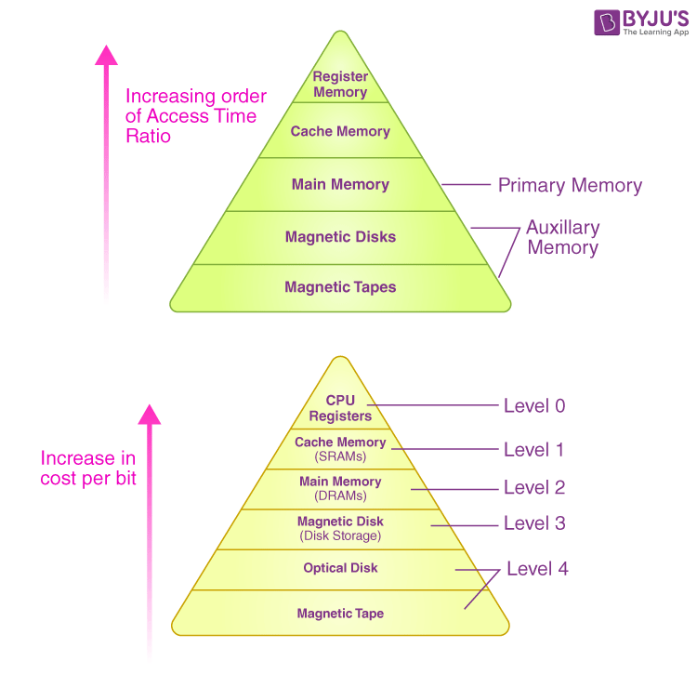

This Hierarchy Design of Memory is divided into two main types. They are:

**External or Secondary Memory**

It consists of Magnetic Tape, Optical Disk, Magnetic Disk, i.e. it includes peripheral storage devices that are accessible by the system’s processor via I/O Module.

**Internal Memory or Primary Memory**

It consists of CPU registers, Cache Memory, and Main Memory. It is accessible directly by the processor.

**Characteristics of Memory Hierarchy**

One can infer these characteristics of a Memory Hierarchy Design from the figure given above:

**1. Capacity**

It refers to the total volume of data that a system’s memory can store. The capacity increases moving from the top to the bottom in the Memory Hierarchy.

**2. Access Time**

It refers to the time interval present between the request for read/write and the data availability. The access time increases as we move from the top to the bottom in the Memory Hierarchy.

**3. Performance**

When a computer system was designed earlier without the Memory Hierarchy Design, the gap in speed increased between the given CPU registers and the Main Memory due to a large difference in the system’s access time. It ultimately resulted in the system’s lower performance, and thus, enhancement was required. Such a kind of enhancement was introduced in the form of Memory Hierarchy Design, and because of this, the system’s performance increased. One of the primary ways to increase the performance of a system is minimising how much a memory hierarchy has to be done to manipulate data.

**4. Cost per bit**

The cost per bit increases as one moves from the bottom to the top in the Memory Hierarchy, i.e. External Memory is cheaper than Internal Memory.

**Design of Memory Hierarchy**

In computers, the memory hierarchy primarily includes the following:

**Registers**

The register is usually an SRAM or static RAM in the computer processor that is used to hold the data word that is typically 64 bits or 128 bits. A majority of the processors make use of a status word register and an accumulator. The accumulator is primarily used to store the data in the form of mathematical operations, and the status word register is primarily used for decision making.

**2. Cache Memory**

The cache basically holds a chunk of information that is used frequently from the main memory. We can also find cache memory in the processor. In case the processor has a single-core, it will rarely have multiple cache levels. The present multi-core

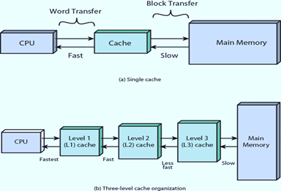

processors would have three 2-levels for every individual core, and one of the levels is shared.

**3. Main Memory**

In a computer, the main memory is nothing but the CPU’s memory unit that communicates directly. It’s the primary storage unit of a computer system. The main memory is very fast and a very large memory that is used for storing the information throughout the computer’s operations. This type of memory is made up of ROM as well as RAM.

**4. Magnetic Disks**

In a computer, the magnetic disks are circular plates that’s fabricated with plastic or metal with a magnetised material. Two faces of a disk are frequently used, and many disks can be stacked on a single spindle by read/write heads that are obtainable on every plane. The disks in a computer jointly turn at high speed.

**5. Magnetic Tape**

Magnetic tape refers to a normal magnetic recording designed with a slender magnetisable overlay that covers an extended, thin strip of plastic film. It is used mainly to back up huge chunks of data. When a computer needs to access a strip, it will first mount it to access the information. Once the information is allowed, it will then be unmounted. The actual access time of a computer memory would be slower within a magnetic strip, and it will take a few minutes for us to access a strip.

Deepthi

H.no 3-22

Bapulapadu,H.junction

Krishna

Andhra Pradesh

22 october 2025

The Hotel Manager  
Vikrant & Co., Manali  
Himachal Pradesh- 360087

Subject- Complaint and feedback letter

Dear Sir

I wish to inform you about my stay at your hotel from 02/03/2021 to 06/03/2021. I regret to inform you that my family and I are quite unsatisfied with the stay at your hotel.

We came to know about your hotel from a travel site. Although the pictures and reviews were quite decent, the actual experience didn’t conform to the standards. For instance, the bed sheets and quilts were dirty; the staff was not cooperative and the room service was slow. We were made to pay separately for the cab service even though the website mentioned that the accommodation charges included a free cab.

I suggest you look into these matters carefully as they will help to improve your service and ensure a better experience for the customers. Moreover, it would be better if you could mention the correct information about the facilities, which you are willing to provide on the partner websites.

Thanking you  
Yours truly  
Sudip Mishra

Rupa

D.no 4-55

BHEL apartment

Airport Road,Hyderabad  
Telangana

12th June 2022

The Editor  
The Times  
New Delhi

Subject: An appeal to raise concern about the incorrect disposal of protective masks

Sir/Madam

With great respect and faith in the columns of your newspaper, I, ABC, a resident of Airport Road, am writing to you. I want to inform you that face masks, which are widely used for safety against Covid-19, are being discarded in inappropriate locations by a segment of the population.

Face masks are being worn by a growing number of individuals to be safe from the disease, but disposing them away anywhere is not acceptable as it can cause many health related as well as environmental issues. People dump these masks carelessly in places like roadsides, pavements, gardens, etc. The elastic bands on these can pose a death threat for the animals who mindlessly chew them. Also, these are a hub of germs and microbes and can spread infections. Proper disposal of face masks is crucial for prevention of spread of diseases.

I would like to request the residents, through the columns of your prestigious publication, to stop careless discarding of their used masks. The government agencies should sensitize people regarding this issue.

Thanking you in anticipation

Yours sincerely

Rupa